# Weather Image Classification Using CNN



CEP Report

By

|  |  |
| --- | --- |
| NAME | RegistrationNumber |
| Aliyan Ahmed Cheema | CUI/FA22-BCE-028 /LHR |

For the course

# Artificial Intelligence Semester Spring/Fall 2025

Supervised by:

Dr. Farooq

Department of Computer Engineering

COMSATS University Islamabad – Lahore Campus

### DECLARATION

I Aliyan Ahmed Cheema (CUI/FA22-BCE-028/LHR) hereby declare that I have produced the work presented in this report, during the scheduled period of study. I also declare that we have not taken any material from any source except referred to wherever due. If a violation of rules has occurred in this report, I shall be liable to punishable action.

Date: 26th May 2025

Aliyan Ahmed Cheema (CUI/ FA22-BCE-028/LHR)

Student 2 (CUI/ - - /LHR)

Student 3 (CUI/ - - /LHR)

Name4 (CUI/ - - /LHR)

### ABSTRACT

This CEP project aims to classify weather images into categories such as cloudy, rainy, lightning, and sunrise using Convolutional Neural Networks (CNNs). By using a labeled dataset of weather images, a CNN model was trained to recognize visual patterns associated with different weather conditions. The project leverages TensorFlow and Keras to implement and train the model. The results indicate that even with a modest dataset, CNNs can achieve promising accuracy in classifying weather conditions, which could be applied in automated monitoring systems and smart city infrastructure.

iii

##### TABLE OF CONTENTS

1. **Introduction 1**
2. **Literature Survey 2**
3. **Proposed Methodology 3**
4. **Simulation Results 4**
5. **Conclusions 5**
6. **References 6**
7. **Appendix 7**

iv

##### LIST OF FIGURES

**Fig: 3.1 Flow Chart of Weather Classifier 3**

**Fig: 4.1 Accuracy vs Epoch Graph 4**

**Fig: 4.2 Confusion Matrix 4**

v

##### LIST OF ABBREVIATIONS

CNN Convolutional Neural Network  
 SDG Sustainable Development Goal  
 GPU Graphics Processing Unit  
 ReLU Rectified Linear Unit

vi

### Introduction

This project uses a deep learning-based image classification system to automatically identify weather conditions such as cloudy, lightning, rainy, and sunrise. The increasing demand for automated environmental systems inspired this project. It helps reduce manual weather reporting and supports smart city infrastructure.

##### Objectives

- To build an image classifier using CNNs.  
- To train the model using labeled weather image datasets.  
- To evaluate the model using metrics like accuracy and confusion matrix.  
- To analyze and interpret the results for real-world applicability.

##### Features and Cost Estimate of our Project

No hardware cost. Software used: Python, TensorFlow, Keras, Google Colab (free GPU usage).

1

### Literature Survey

Existing literature on weather classification primarily relies on sensors or traditional machine learning. Convolutional Neural Networks (CNNs) offer improved accuracy by learning features directly from image data without manual feature extraction.

2

### Proposed Methodology

A CNN model was designed with three convolutional layers followed by max pooling and a dense output layer. The dataset was split into training and validation sets. Accuracy and confusion matrix were used for evaluation.

**Flow Chart / Algorithm**

1. Load and preprocess images  
2. Build CNN model  
3. Train model  
4. Validate and evaluate  
5. Analyze results

**Fig: 3.3 Flow chart**

3

### Simulation Results

The model was trained over 10 epochs using categorical cross-entropy loss and Adam optimizer. Training and validation accuracy improved gradually. Evaluation showed reasonable classification accuracy for 4 weather types.

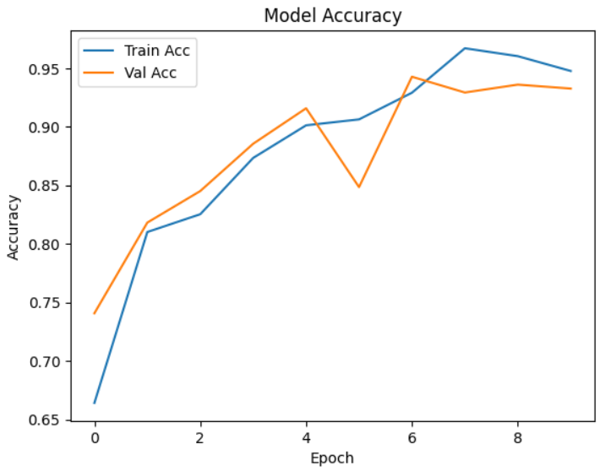

## Conclusions

This project demonstrated the effectiveness of CNNs in classifying weather images. It laid a foundation for real-world weather automation and opens future possibilities for integration with real-time systems.

5

## References

[1] Chollet, F. (2017). Deep Learning with Python. Manning Publications.  
  
[2] https://www.kaggle.com/datasets/tamimresearch/weather-image-dataset – Weather Image Dataset (Accessed: 24-05-2025)  
  
[3] TensorFlow Documentation. https://www.tensorflow.org (Accessed: 24-05-2025)

6

## Appendix

#### [Colab Code](https://colab.research.google.com/drive/1fwKaQ-oMpx4gxEfanjd1aoFWWBcKc-Jf?usp=sharing)